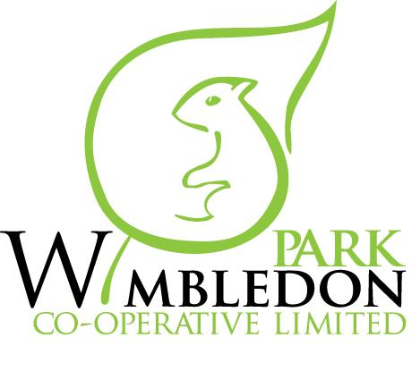

WIMBLEDON PARK CO-OPERATIVE ANNUAL GENERAL MEETING
Held on Wednesday 5 July 2017 at 7:30 pm at
2 Fernwood Meeting Room

MINUTES
Meeting chaired by Bernard Koudjo

- Present
Committee Members
Bernard Koudjo [Chair]
Anne Bzowska [Secretary]
Phyllis Edwards [Treasurer]
Stephen Johnson [Board Member]
Charlene Hinds [Board Member]

Other Attendees
Junelle Carter Johnson [Housing Officer]
Bernard Brennan [WBC Resident Participation Officer]
Members: L Bensohn, Marion Brown, J Harvey, Sarah King, Sally Masson, Mary O’Shea, Hugo Pastor, Kathleen Ryan, Linda Stevens, Kirsty Tozer, Sam Tozer, Michel Tyler, Shaun Wilcox

2. Apologies
Sam Seager [Board Member]

3. Minutes of the previous Annual General Meeting
The minutes of the July 2016 AGM were approved and signed.

- Chair’s Report on previous year
AB detailed staff changes that had occurred over the previous year.

- Plans for upcoming year
Measures to address the increase of fly tipping around Allenswood will be put in place this year. New bin chambers and landscaping is planned.

- Continuation Vote
A majority of 16 members voted for the continuation of the co-op and 2 abstained. There were none against. The co-op will, therefore, continue to manage the estate.

- Presentation of audited accounts
The annual accounts have been received but not yet approved by the board. These will be presented at the October General Meeting.

- Appointment of Auditor
It was confirmed that the co-op intends to retender for the role of auditor in the coming year. Our current auditor, K Johnson, will be invited to re-tender.

- Election of Board Members
Pete Karolewski, Charlene Hinds and Bernard Koudjo all stood down and Charlene and Bernard put themselves forward for a further year. LS proposed and AB seconded Bernard’s re-election to the board. MB proposed and PE seconded Charlene’s re-election to the board. Kirsty Tozer volunteered to join the board. BK proposed and AB seconded her election.

- Any Other Business
The tree survey has been carried out and Junelle will give the council the go ahead to proceed with the work.
The gardening contract has been extended for one year. The head gardener will be asked to meet with residents to hear their concerns and specific requests.
Concern regarding malfunctioning fire doors in Allenswood staircases was raised. Junelle confirmed that a works order to fix all the doors has been raised and the work is scheduled to take place shortly.
BB advised that Fire Prevention and Evacuation Procedures are currently under review in the light of the recent tragedy at Grenfell Tower. He brought and distributed Fire Safety Leaflets and advised that the Fire Brigade can be contacted to inspect homes and supply smoke alarms free of charge.
SW pointed out that the Electrical Intake cupboard on the second floor of the staircase in Fernwood is not secured.

- Date of Next General Meeting [10th October 2017]

