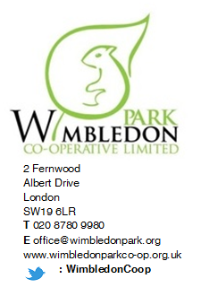

All Residents
Wimbledon Park Estate

Thursday, 30 January 2020

Dear Resident

RE: Contact details

The Housing Officer are currently carrying out an audit of tenancys and leases on the Estate. In order to ensure that our records are up to date we are asking all residents of the Wimbledon Park Estate to complete the attached contact details forms so we can ensure we only hold the most up to date contact details for people living with, or associated with, the Estate.

It is essential that we hold current phone numbers for tenant, leaseholders, private tenants and their managing agents to enable our office to take swift action in emergencies.

Please complete the back of this form and return it to the office through the letterbox at your earliest convenience. Alternatively, you can provide the required information via email at office@wimbledonpark.org or download a copy of this form from our website www.wimbledonparkco-op.org.uk

To ensure that we don’t have out of date details held on file for any households, we will be removing any details we currently currently hold on the 28th March 2020 and going forward will only use the new details provided.

We thank you in advance for your co-operation with this matter.

Yours sincerely,

Lizzie Inglis
Wimbledon Park Co-Operative Management Team

Wimbledon Park Co-op Contact Details

Estate Address:
Name(s):
Type of Residency: | I am a:  Council Tenant (you pay your rent to the Council)  Private Tenant (you pay your rent to an estate agents or private landlord)  Leaseholder (you own your property)
Daytime Phone Number:
Email Address:

If you are a private tenant of an estate agents or private landlord please fill out the following section:

My landlord is: | A private individual  An estate agent or lettings agent
Their contact number:
Their contact email:

Your Co-op is going Green and we need your help! Where possible the co-op would like to reduce our effect on the environment by sending correspondence via email. Please tick your preference below.

Please send all future correspondence to my email address only, including estate newsletters, event invitations and block notices.

Please only email me correspondence directly related to my address

Please continue to send me postal correspondence only

Please note there may still be occasions where postal correspondence is necessary. You can opt out any time by letting us know. If you move of the estate please inform the office ASAP to have you details removed from our database.

